**Semester Project Report**

on

**“****COLLEGE & UNIVERSITY ELECTION CONDUCTIONG PROGRAM”**

Submitted in partial fulfillment of requirements for the award of degree of Bachelor of Engineering in Computer Science and Engineering.

Submitted To:



**Lakshmi Narain College of Technology University, BHOPAL(M.P)**

Submitted By:

RAGHAW KUMAR

**LNCBBTCSE087**

­­­­

Under the guidance of:

**Prof. Vineeta Shrivastava**

DEPARTMENT OF COMPUTER SCIENCE AND ENGINEERING

LNCT University, Bhopal, Madhya Pradesh(462002)

Session 2021-22



**COLLEGE & UNIVERSITY ELECTION CONDUCTIONG PROGRAM Project Report**

**Developed & Submitted By:**

Name**:Raghaw Kumar**

**1st Semester**

Date:-22/02/2022

**DECLARATION**

I,RAGHAW KUMAR, hereby declared that this project work entitled “PHONEBOOK MANAGEMENT SYSTEM” submitted to **LNCT University** is original record work done by me under the supervision and guidance of **Prof. Vineeta Shrivastava** Department of COMPUTER SCIENCE.

Name Of Student Enrollment No. Signature of Student

RAGHAW KUMAR LNCBBTCSE087 ………………………

CONSIGNED BY:

**Prof. Vineeta Shrivastava**

Teacher in Charge

Department of Computer Science

**LNCT University**

**B.Tech CSE**

­­**ACKNOWLEDGMENT**

The success of final outcome of this project required a lot of guidance and assistance from many people and I am extremely fortunate to have got this all along the completions of my project work. Whatever I have done is only due to such guidance and assistance and I would not forget to thank them.

I have taken efforts in this project. However, it would not have been possible without the kind support and help of many individuals. I would like to extend my sincere thanks to all of them.

I am highly indebted to my computer teacher **Prof. Vineeta Shrivastava** for her guidance and constant supervision as well as for providing necessary information regarding the project & also for supporting mein completing this project.

I am thankful to and fortunate enough to get constant encouragement, support and guidance from all teaching staff of Department of computer science which helped us in successfully completing this project.

I would like to express my gratitude towards my parents for their kind co-operation and encouragement which help me in completion ofthis project.

My thanks and appreciations also go to my colleague in developing the project and people who have willingly helped me out with their abilities.

**CONTENTS**

1. **Overview of C-language**
2. **About this Project**
3. **System Requirements**
4. **Flow-diagram**
5. **Source Code**
6. **Sample Outputs**
7. **Conclusion**

**1)Overview in C**

Welcome to the tutorial series for C language. This is the best C language tutorial set on the Internet, that will help you learn the C language.

C language was developed by **Dennis Ritchie in 1972 at Bell Laboratories**. In 1989, the C language was standardized, where C language features were defined, also known as the **1989 ANSI standard** for C, and that is the reason, you will see C language also called **C89**, because of the 1989 ANSI standard.

The current latest version of the C language is **C99**, as some new features were added to the C language in **1999**.

You must be thinking, 1999 was more than 20 years ago, but the **C language is still very relevant** and **widely used** although there are many other new languages like C++, Java, Python, C#, etc. in the market.

C Language is a **middle-level**, **structured programming language**, that **needs a compiler** for running the programs written in C language. Do not worry about these terms, we will cover all of them in detail in this tutorial.

**2)About this project**

* **It is a console based College /university Election system.**
* **From this we can conduct election and chose candidate**
* **We also can conduct new election year wise.**
* **The system is completely believable**
* **It is made by C-Programming language**
* **It is easy to use.**



**Technique Used:**

C-Programming language

File Handling

**SYSTEM REQUIREMENT**

**Hardware Required:**

**Operating System: Windows 98, 2000, XP , Vista, 7, 8, 8.1, 10, 11**

**Memory: 512 Mb RAM**

**Storage: 60 Mb**

**Software Required:**

GCC Version 9.2.0

Command Prompt

Visual Studio Code

**Header file used:**

#include <stdio.h>

#include<conio.h>

#include<string.h>

#include<stdlib.h>

Start

Menu

If choice is 1

Student panel

If choice is 2

Admin panel

If choice is 3

End

Conduct new vote calculate result

True

True

True

**False**

**If input 0**

False

Logout

True

**Fig: Flow chart**

False

User id correct can vote

**Sample output:**

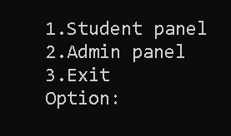

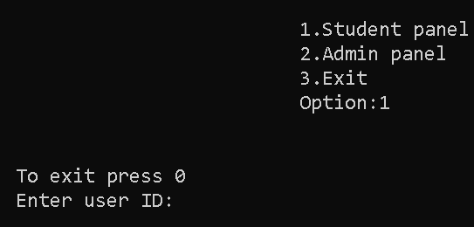

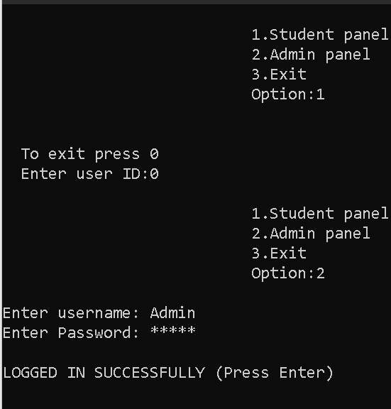

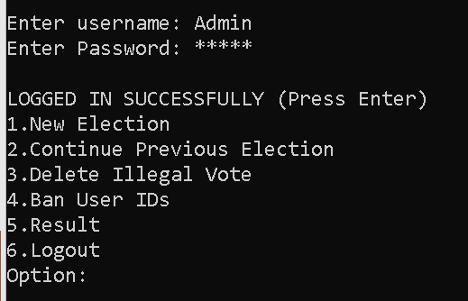

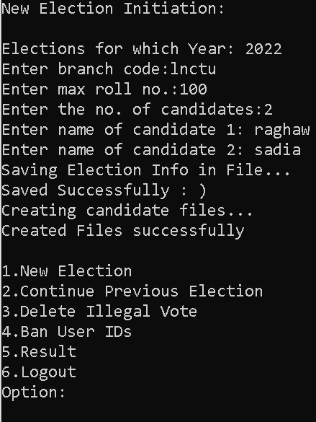

**Conclusion**

* **In past, when technology is not evolved it is difficult to Conduct election by this program we can easily save and read phonebook**
* **This is console base Election conducting program made in C-programming language**
* **Data is stored in hard disk permanently by using file handling**